Atharva Yadav

Roll No. 127

Batch S23

NETWORK LAB ASSIGNMENT NO.3

Aim: Implementation of specific network topology which is supported in TCP.

Theory:

In wireless networks nodes communicate Using Communication model that consist of TCP agent, TCP sink agent and FTP Application .

The sender node is attach to TCP agent The receiver node is attach to TCP sink agent The connection between TCP agent and TCP Sink agent is establish using keyword "connect".

In Transport Layer,TCP agent and the FTP Application are connected using keyword "attach-agent".

On receiving packet TCP sink agent sent the acknowledgment to the TCP agent that in turn Process the acknowledgment and adjust the data- transmission rate, The loss of packet are interpreted as sign of congestion.

CODE :

#Create a Simulator Object set ns [new Simulator]

#Open the NAM trace file set nf [open out.nam w] $ns namtrace-all $nf set np [open out.tr w]

$ns trace-all $np

#define finish procedure proc finish {} { global ns nf np $nsflush-trace #Close NAM Trace close $nf

#Execute NAM on the tracefile exec nam out.nam & exit 0 }

#create two nodes set n0 [$ns node] set n1 [$ns node] set n2 [$ns node] set n3 [$ns node]

#Create links between all nodes

$ns duplex-link $n0 $n1 2Mb 10ms DropTail

$ns duplex-link $n1 $n2 2Mb 10ms DropTail

$ns duplex-link $n2 $n3 2Mb 10ms DropTail #set Queue Size

$ns queue-limit $n0 $n1 5

$ns queue-limit $n1 $n2 5

$ns queue-limit $n2 $n3 5

#Monitor The queue for link (n0-n1)

$ns duplex-link-op $n0 $n1 queuePos 0.5

$ns duplex-link-op $n1 $n2 queuePos 0.5

$ns duplex-link-op $n2 $n3 queuePos 0.5

#Set up a TCP connection set tcp [new Agent/TCP] $ns attach-agent $n1 $tcp set sink [new Agent/TCPSink] $ns attach-agent $n2 $sink

$ns connect $tcp $sink

#Set up a TCP connection set tcp [new Agent/TCP] $ns attach-agent $n0 $tcp set sink [new Agent/TCPSink] $ns attach-agent $n1 $sink

$ns connect $tcp $sink #Set up a TCP connection set tcp [new Agent/TCP] $ns attach-agent $n1 $tcp set sink [new Agent/TCPSink] $ns attach-agent $n2 $sink

$ns connect $tcp $sink #Set up a TCP connection set tcp [new Agent/TCP] $ns attach-agent $n2 $tcp set sink [new Agent/TCPSink]

$ns attach-agent $n3 $sink

$ns connect $tcp $sink #Set up a TCP connection set tcp [new Agent/TCP] $ns attach-agent $n0 $tcp set sink [new Agent/TCPSink]

$ns attach-agent $n3 $sink

$ns connect $tcp $sink

#Set Packet Colour

$tcp set fid_ 4

#Set up FTP Protocol (Application Layer) over TCP (Transport Layer) set ftp [new Application/FTP]

$ftp attach-agent $tcp

#Schedule Events for FTP agents

$ns at 0.1 "$ftp start"

$ns at 4.0 "$ftp stop"

$ns at 5.0 "finish"

#Run Simulator

$ns run

OUTPUT :

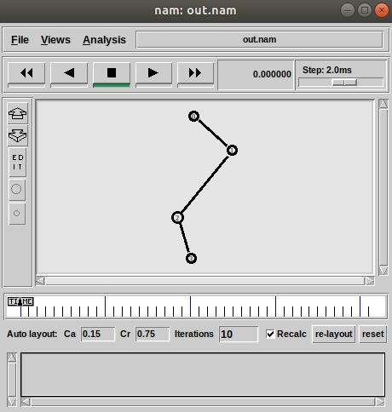

CONCLUSION : Network assignment on implementing a specific network topology with TCP This equips you with a strong understanding or mesh) using network devices and software. Additionally, we delved into the implementation of TCP (Transmission of how network structure and protocols interact.We explored how to configure a chosen network topology (like star, bus, Control Protocol) within this topology, ensuring reliable data transfer between devices. By successfully combining these concepts, we gained valuable practical experience in designing and implementing network communication.

LO: BASED ON LO3 : To understand the network simulator environment and visualize a network topology and observe its performance